Civil war in Somalia

UNSC Resolution: | 794
Date of adoption: | 3-Dec-1992
Operative paragraph: | 3
Demand number: | 794,0311

Sarah-Myriam Martin-Brûlé

Wording of demand

take all measures necessary to ensure the safety of United Nations and all other personnel engaged in the delivery of humanitarian assistance, including the military forces to be established pursuant to the authorization given in paragraph 10 below

List of addressees of the demand

Government of Somalia, United Somali Congress Faction

Short-term compliance

Description of the addressee(s)’ conduct

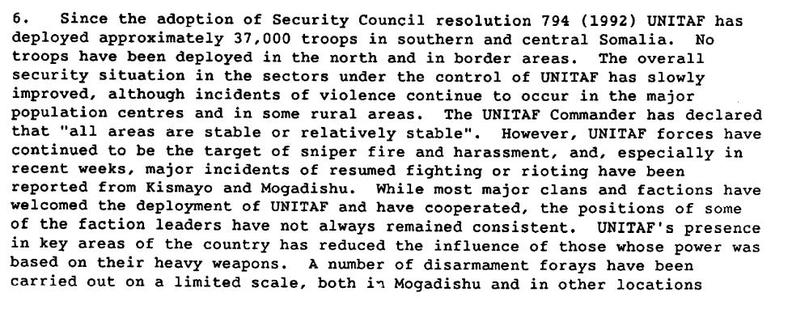
Further Report of the Secretary-General submitted in pursuance of paragraphs 18 and 19 of resolution 794 (1992), 3 March 1993, S/25354

Assessment

Short-term compliance
No or marginal compliance (1) | Medium low compliance (2) | X Medium high compliance (3) | Full or almost full compliance (4)

Considerations underlying the assessment

Within the six months following the adoption of the resolution, albeit the continuation of hostilities, the demand addressees took significant measures necessary to ensure the safety of United Nations and all other personnel engaged in the delivery of humanitarian assistance, including the military forces to be established pursuant to the authorization given in paragraph 10 below.

Medium-term compliance

Description of the addressee(s)’ conduct

10. The port of Mogadishu was reopened after many months, and substantial quantities of food and other essential supplies were brought in. Both the port and the airport were put to full use, and improvements were also made to airports and airstrips in rural areas to cope with the massive airlifts of relief. At the same time, repair work was carried out on the major relief supply routes, and some mine clearance was undertaken. A fleet of trucks was brought in from neighbouring countries to accelerate the delivery of humanitarian assistance.
http://daccessdds.un.org/doc/UNDOC/GEN/N93/564/88/PDF/N9356488.pdf?OpenElement

14. In spite of the presence of UNITAF, the risk to relief workers remained high. A number of Somali and expatriate relief personnel were killed. Theft, looting and extortion continued to plague relief efforts. The resettlement of some 1 million internally displaced people and hundreds of thousands of refugees could not proceed owing to security problems. Armed bands began to create havoc in new areas, including neighbouring countries that had offered hospitality to
Somali refugees.
http://daccessdds.un.org/doc/UNDOC/GEN/N92/109/47/PDF/N9210947.pdf?OpenElement

Assessment

Medium-term compliance
X No or marginal compliance (1) | Medium low compliance (2) | Medium high compliance (3) | Full or almost full compliance (4)

Considerations underlying the assessment

Within the two years following the adoption of the demand, the demand addressees ddid not take all measures necessary to ensure the safety of United Nations and all other personnel engaged in the delivery of humanitarian assistance, including the military forces to be established pursuant to the authorization given in paragraph 10 below

Depth of demand

Assessment

Level of depth of demand
Low depth of demand (1) | X Medium depth of demand (2) | High depth of demand (3)

Considerations underlying the assessment
Compliance with this demand made it significantly more difficult for the demand addressees to attain victory in the civil war.
In fact, ensuring the safety of United Nations and all other personnel engaged in the delivery of humanitarian assistance paradoxically became an incentive to maintain the insecurity of the setting in order to boost the demand for greater protection.

Rutherford thus explains:

“NGO hiring and firing practices also led to rising violence against NGOs (…)Somalis fought amongst themselves for the large contracts (…)
‘The efforts of NGOs, the United Nations and the International Committee of the Red Cross to provide their own private armies of security guards to protect relief commodities and infrastructure in Somalia not only failed but also exacerbated the violence racking the country. By creating a demand for weapons and ammunition far beyond what the warlords ever caused, humanitarian organizations inadvertently encouraged the importation of weapons.”

Kenneth Rutherford. 2008. Humanitarianism Under Fire: The US and UN Intervention in Somalia. Kumarian Press,p .95

Level of confidence about coding decisions

Level of confidence about coding decision
Extremely high | X High | Moderate

Comments to IPI (if any)

